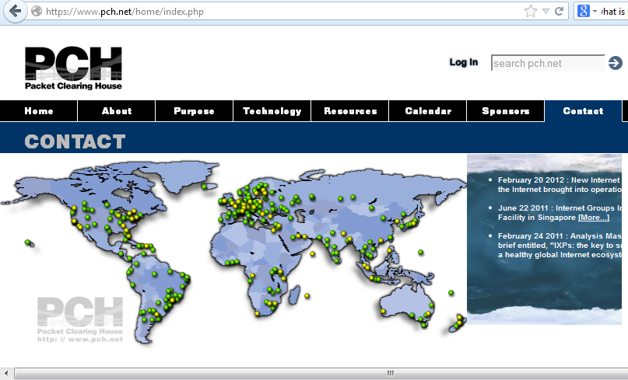

Packet Clearing House is a non-profit research institute that supports operations and analysis in the areas of Internet traffic exchange, routing economics, and global network development.
Originally formed in 1994 to provide efficient regional and local network interconnection alternatives for the west coast of the United States, PCH has since grown to become the leading proponent of neutral independent network interconnection and provider of route-servers at major exchange points worldwide.
Today, PCH provides equipment, training, data, and operational support to organizations and individual researchers seeking to improve the quality, robustness, and accessibility of the Internet. Current and ongoing PCH projects include the construction of Internet Exchanges Points (IXPs) throughout the developing world; operation of the INOC-DBA global Internet infrastructure protection hotline; support for globally distributed domain name system (DNS) resources; implementation of network research data collection initiatives in more than three dozen countries; and the development and presentation of educational materials to foster a better understanding of Internet architectural principles and their policy implications among policy makers, technologists, and the general public.

PCH operation:
INTERNET EXCHANGE SUPPORT
Packet Clearing House provides support both to Internet exchange facilities in the process of formation and to those that are already up and running. Although we supply the switching equipment that forms the technological core of exchanges, often our most valuable contribution is in the form of education, technical expertise, and mediation with policy and economic officials of the local government.
In forming new Internet exchanges, PCH facilitates a multi-phase process that typically takes about six months: we organize local stakeholders in an unserved region to form an independent, not-for-profit industry association; guide that association through the necessary decisions regarding organizational, financial, and governance structure; work with government in the region to ensure a beneficial regulatory climate; assist them with site selection and preparation; and finally organize an intensive week-long series of classes and workshops that culminates in the physical turn-up of the exchange facility and its inauguration with production traffic.
When PCH is called in to work with a preexisting exchange, it is typically to assist with a transition or overcome a newly encountered technological or economic hurdle. Frequently a change in the competitive environment renders an exchange's business model ineffective, and we work with the exchange, its member-participants, and regulatory authorities to create a new business model that satisfies each of the stakeholders and provides long-term financial stability.
ROUTE SERVERS
In addition to providing the OSI Layer-2 switch gear that forms the core of an Internet exchange, PCH also provides Layer-3 route servers to facilitate easier and safer interconnection between participants at the exchange. Unlike global-scale backbone networks, smaller regional and local service-provider networks often have small technical staffs. If they are connecting to an exchange for the first time, as is often the case when we construct new exchanges, they typically lack expertise in the area of multi-homed routing. Route servers can greatly accelerate the turn-up of such new exchanges by allowing each participating network to configure a single logical routing adjacency ("peering session") with the route server rather than a full mesh of individual adjacencies with each of the other participants. As new participants join the exchange, they receive the immediate benefit of full use of the exchange as soon as they contact the route server, rather than incrementally gaining use of the exchange as they configure each of many peering sessions. Route servers also increase the degree of safety to the participants, since their filters ensure the accuracy of the routing information that passes through them. This filtering prevents the widespread propagation of network outages caused by participants' accidental misconfiguration of routers.
INTER-NOC HOTLINE PHONE SYSTEM
Packet Clearing House operates the Inter-Network Operations Center Dial-By-ASN (INOC-DBA) hotline phone system, a global voice telephony network that connects the network operations centers and security incident response teams of critical Internet infrastructure providers such as backbone carriers, Internet service providers, and Internet exchanges as well as critical individuals within the policy, regulatory, Internet governance, security and vendor communities. The INOC-DBA is a closed system, ensuring secure and authenticated communications, and uses a combination of highly redundant directory services and direct peer-to-peer communications between stations to create a resilient, high-survivability network. It carries both routine operational traffic and emergency-response traffic.

NPIX
